***Zomato* Restaurant Expansion Analysis**

**Objective Questions**

**1 What is the total no. of tables present in the data?**

* There are two tables present in the data one in sheet named “raw data” and sheet “country description”

**2 What is the total no. of attributes present in the data?**

* There are 24 attributes present in the data.
* One way attribute can be counted is by using a IF formula :
* =ArrayFormula(SUM(IF(data!$A1:$AA1 <> "",1,0)))

**3 How many categorical columns are there in the data? [Search about categorical and continuous data, and try to answer this question]**

* categorical variable belongs to fixed category and continuous variables are numerical variables that do not belong to any category.
* There are 12 categorical columns.

**4 The data consists of some inconsistent and missing values so ensure that the data used for further analysis is cleaned.**

**Approach:**

In the dataset, there was a missing 'Country' column, and spelling mistakes were present, which could have caused issues in data analysis by leading to inconsistencies during grouping or filtering. Additionally, the 'Cuisine' column had 7 missing values.

Since these missing values represented a small fraction of the dataset, I addressed the issue by **deleting the corresponding rows**. This ensures data integrity, as those incomplete records are now removed, and the dataset is clean for accurate analysis.

**5 Using the LookUp functions, fill up the countries in the original data using the country code.**

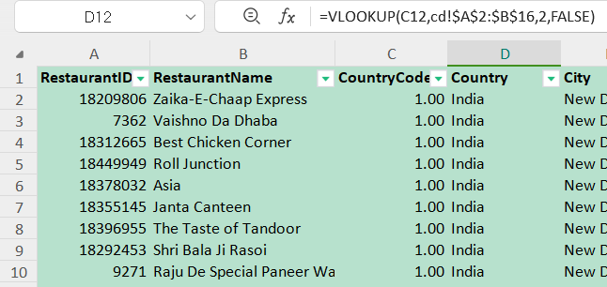

**Approach**:

Vertical LookUp is the appropriate fit to solve this problem

Formula - =VLOOKUP(C2, cd!$A$2:$B$16, 2, FALSE)

**6 Create a table to represent the number of restaurants opened in each country.**

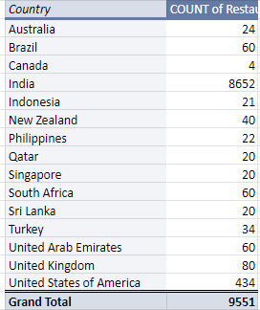

**Approach**:

By creating a pivot table and using country as rows and restaurant id has values we can get number of restaurants in each country.

**7 Also, the management wants to look at the number of restaurants opened each year, so provide them with something here.**

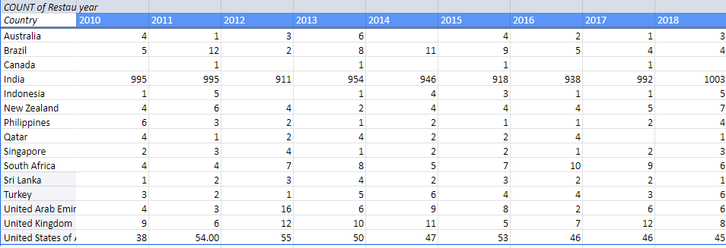

Approach:

By creating a pivot table where country is in the rows and year is in the columns and restaurant id count in the values.

**8 What is the total number of restaurants in India in the price range of 4?**

Approach:

By using conditional aggregation functions we can count the restaurant ids which are in the price range of 4.

Formula: =COUNTIFS(data!$Q2:$Q9552 ,"<4",data!$D2:$D9552,"=India")

**9 What is the average number of voters for the restaurants in each country according to the data?**

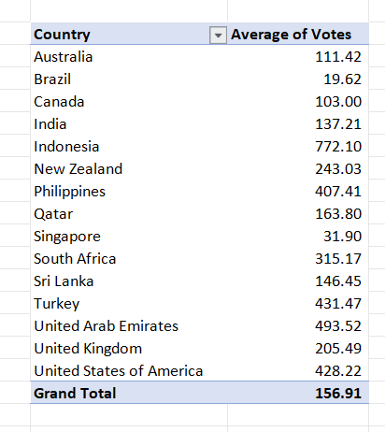

Approach:

A pivot table can be used to calculate average number of votes. We need to place country in rows section and votes in values section.

**10 Calculate the average rating for all the restaurants that have price_range < 4 and provide online delivery. Use only the “IF” function, Logical Operators, and Aggregation functions to solve this problem. [Note: Don’t use Conditional aggregation in this question.]**

=ArrayFormula(AVERAGE(IF((data!$Q2:$Q9552 < 4)*(data!$N2:$N9552 = "Yes"),data!$T1:$T9552)))

**Output:-**

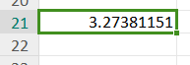

**11 Using Conditional formatting highlight the rows of restaurants that are located in the countries or cities that you’ve suggested to the management for opening new restaurants.**

Singapore:

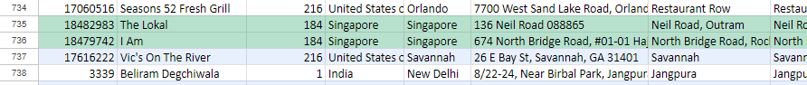

Canada:

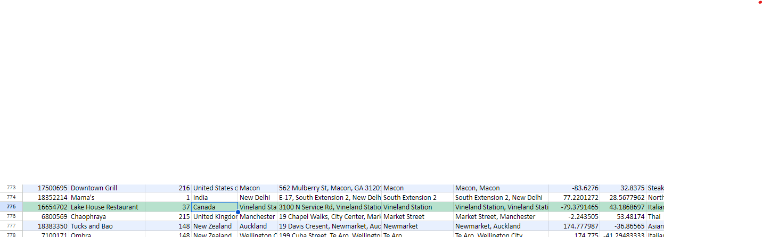

Australia:



**12 Create a new customized price column that consists of the abbreviation/symbol of the currency along with the Average_cost_for_two value. [Use string operations to do this task]**

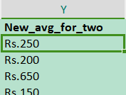

**Approach** :

To get the symbol from the country column we need regex extract and string concat function.

With regex extract we get the symbol from the parenthesis and by using concat function both the value and symbol can be joined.

**Formula**:

=CONCAT(REGEXEXTRACT($L2,"\(([^)]+)\)"),$S2)

**13 How can you create an array formula in Excel or Google Sheets to count the number of restaurants listed that do not offer online delivery, are in the lowest price range, and have an average cost for two people less than or equal to 250 Indian Rupees?**

array formula

**Approach**:

In google sheets Array formula can be created by pressing ***ctrl + Shift + Enter*** once we have written the formula.

**Formula**:-

=SUM((data!$O2:$O9552="No")*(data!$R2:$R9552=MIN(data!$R2:$R9552))*(data!$Z2:$Z9552<=250))

**Subjective Question**

**1 Suggest a few countries where the team can open newer restaurants with lesser competition. Which visualization/technique will you use here to justify the suggestions?**

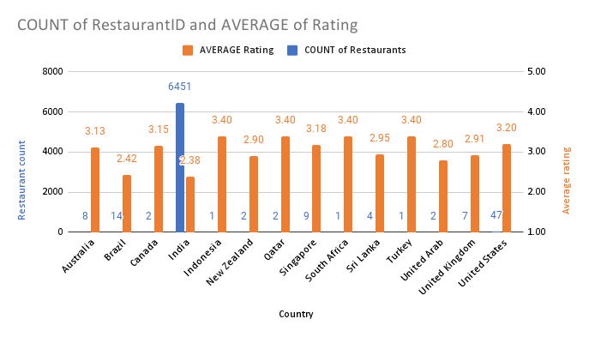

* Countries with fewer restaurants and lower restaurant ratings are potential candidate locations for opening new establishments.
* A combo chart would be appropriate to display the count of restaurants and the average rating, with the average rating represented on the secondary axis for clarity.
* Based on these criteria, the following countries have been identified as potential locations for new restaurants: Canada, Singapore, and Australia.

**2 Come up with the names of States and cities in the suggested countries suitable for opening restaurants.**

The selection of cities for opening new restaurants should be based on a higher price range, lower average ratings, and a limited number of existing restaurants. This strategy is informed by the following considerations:

* **Lower Ratings:** Indicates potential customer dissatisfaction with the price paid, suggesting an opportunity to improve customer experience and value.
* **Fewer Restaurants:** Implies reduced competition, providing a strategic advantage for new entrants in the market.

**Recommended Cities for New Restaurant Openings:**

* Paynesville
* Montville
* Flaxton
* Vineland
* Tanunda
* Consort

**3 According to the countries you suggested, what is the current quality regarding ratings for restaurants that are open there?**

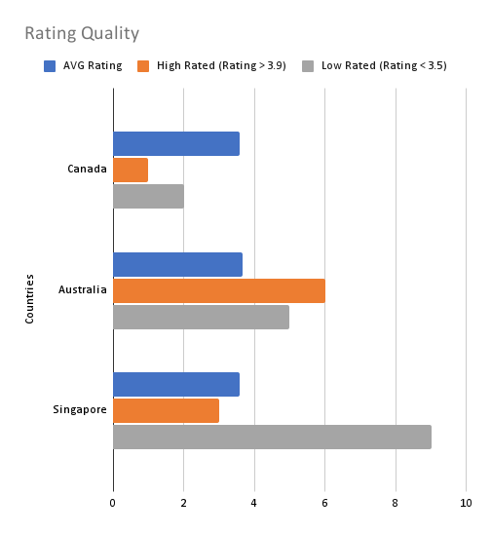

* **Australia:**  
  Australia exhibits the most polarized restaurant scene, characterized by a significant number of both high-rated and low-rated establishments. This diversity presents unique opportunities and challenges for restaurant entrepreneurs looking to enter the market.
* **Canada:**  
  Despite having fewer high-rated restaurants, Canada maintains the highest average quality of dining establishments. This suggests a consistently high standard of service and food across its restaurants, making it a desirable location for discerning diners.
* **Singapore:**  
  Singapore faces challenges with overall restaurant quality, as evidenced by the prevalence of low-rated establishments and the lowest average rating among the countries analyzed. This indicates potential areas for improvement in the dining experience and presents opportunities for new entrants to elevate the market standard.

**4 Also, what is the current expenditure on food in the suggested countries, so we can keep our financial expenditure in control?**

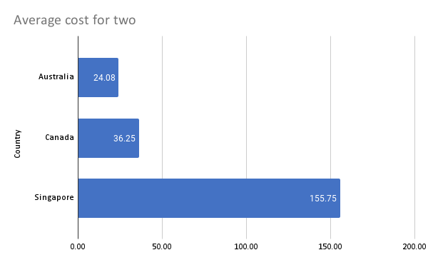

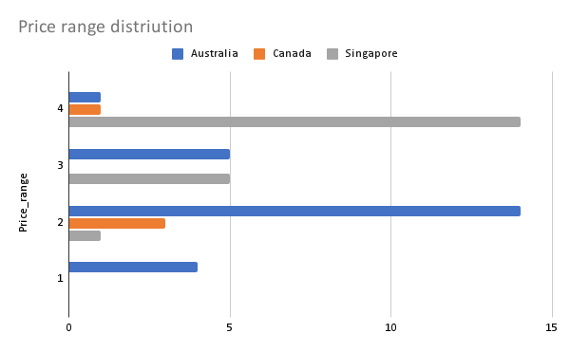

* The **average price range in Singapore** is 3.65, which is significantly higher compared to other countries, indicating that restaurants in Singapore tend to be more expensive. This observation is further supported by the average cost for two people, which is $155.75.
* In contrast, restaurants in Australia and Canada are relatively more affordable. The average cost for two people is $24 in Australia and $36 in Canada. These differences in pricing highlight the variations in dining expenses across these countries, providing insight into market positioning and consumer spending behavior.

**5 Come up with the names of restaurants from the recommended states that are our biggest competitors and also those that are rated in the lower brackets, i.e. 1-2 or 2-3.**

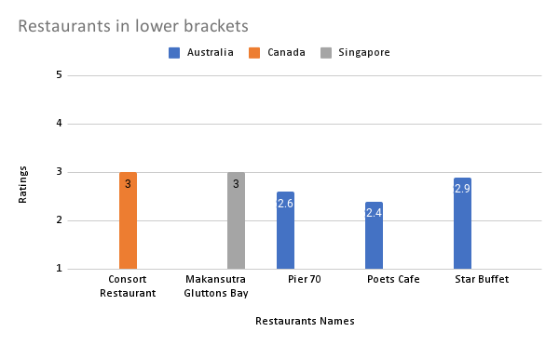

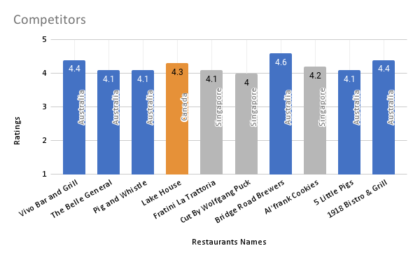

* The chart illustrates the number of restaurants with ratings above 4. In Australia, there are six such restaurants; two of them have a rating of 4.4, and one has a rating of 4.6, indicating significant customer satisfaction.
* In Singapore, there are three restaurants with ratings ranging between 4.0 and 4.2. The difference in ratings between restaurants in Australia and Singapore is minimal. This might be attributed to consumers in Singapore having higher expectations due to the generally higher cost of dining.
* Canada has only one restaurant with a rating of 4.3, suggesting there is less competition in this region.

**6 Which cuisines should we focus on in the newer restaurants to get better feedback? Does the choice of cuisines affect the restaurant ratings?**

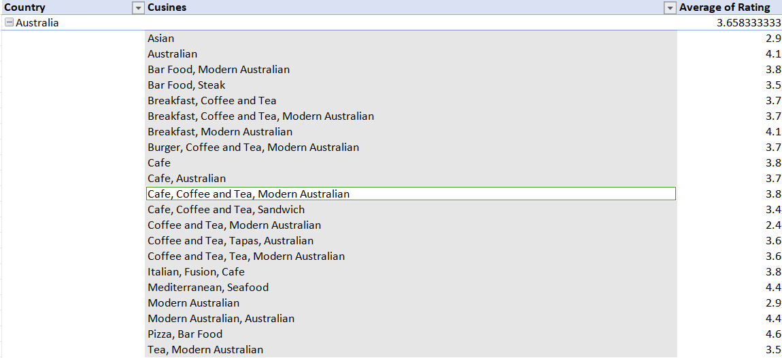



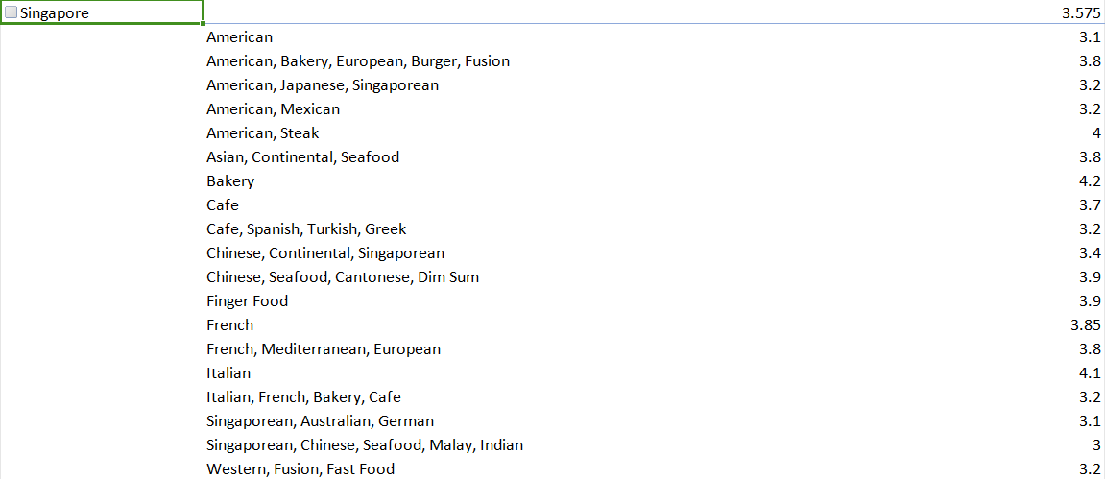

* In Australia, there is a strong preference for modern Australian food, fast food, and cafes. Therefore, the new restaurant should focus on offering Modern Australian cafes to cater to local tastes effectively.
* In Canada, the culinary landscape is quite diverse, with only four prominent restaurants, two of which serve Chinese and Japanese cuisine. This suggests that Canadians have a preference for Asian food. Thus, opening a restaurant that focuses on Asian cuisine would likely be well-received.
* Singapore, being a melting pot of cultures due to its large immigrant population, exhibits a wide variety of cuisines. To appeal to the diverse customer base, establishing a fast-food restaurant with American offerings or a restaurant specializing in Asian cuisine would be strategic.

**7 According to our current data, should we go for online delivery and table booking? Does that affect the customer’s ratings?**

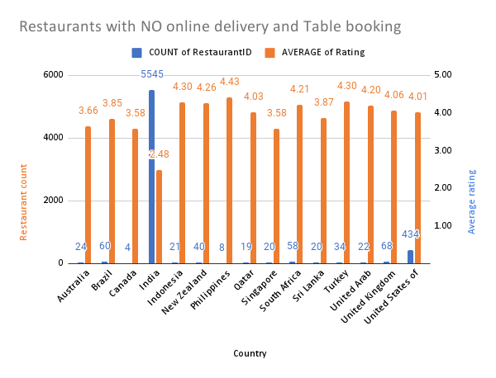

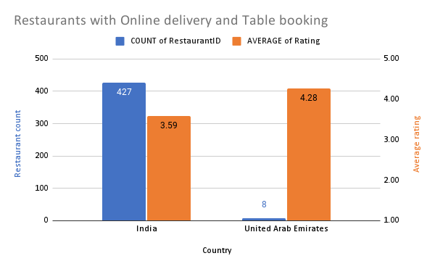

* Singapore has an average rating of 3.58 without online delivery and table booking. The modest average rating suggests there could be potential for improvement. Offering online delivery and table booking might attract more customers who prefer the convenience, potentially improving ratings.
* With an average rating of 3.85, Canada is performing relatively well without these services.Canada's ratings suggest a fairly positive perception even without the additional services. Introducing online delivery and table booking could enhance customer experience, but it might not be as critical as in other markets like India.
* The average rating of australia 3.66, which is slightly better than Singapore but lower than Canada.Given the moderate ratings, implementing online delivery and table booking could improve convenience for customers and potentially increase ratings.

**8 Should the team keep the rate of cuisines higher? Will that affect the feedback? According to our data are the rates of cuisines and ratings, correlated?**

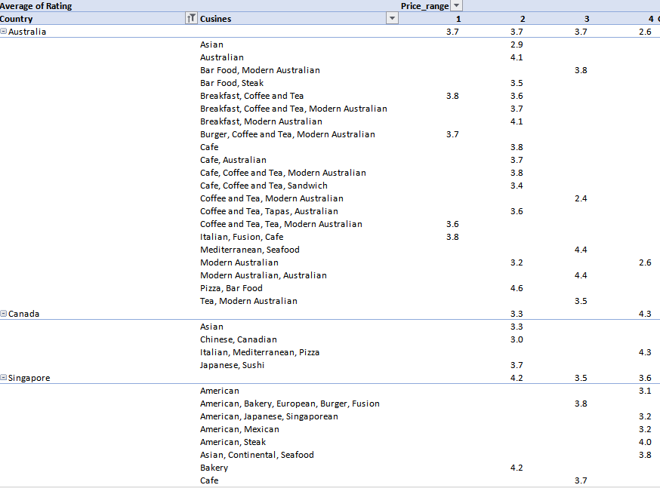

* The relationship between cuisine pricing and ratings is not strongly correlated, as multiple factors contribute to the pricing of cuisines. In many countries, the price of native cuisine tends to be lower due to local availability and familiarity, which often results in reduced costs for ingredients and preparation.
* Furthermore, restaurants that offer a wide variety of cuisines may fall into a lower price range bracket. This is because their diverse offerings cater to a broad spectrum of customer preferences, allowing them to maintain competitive pricing while attracting a wider customer base.

**9 What is the distribution of the number of restaurants of different price ranges in all the countries?**

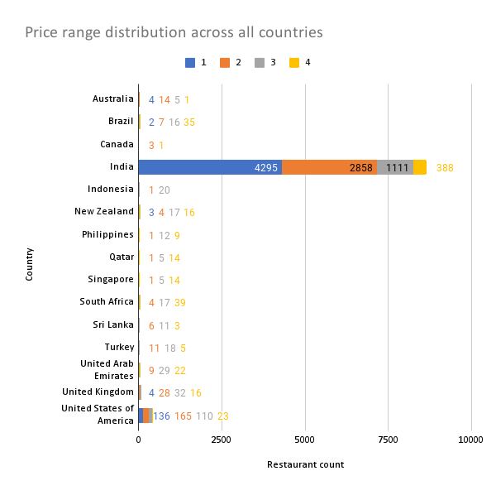

* India has the most restaurants by far, concentrated in lower price ranges.
* The USA has the second-highest count, with a more balanced distribution.
* Most countries have more affordable restaurants (ranges 1-2) than expensive ones.
* Some countries (e.g., Canada, Indonesia) show very low counts.
* Brazil uniquely has more high-end restaurants.
* Countries like Qatar, Singapore, and UAE have relatively even distributions across price ranges.
* The UK and Australia show gradual decreases in restaurant numbers as prices increase.
* Data for many countries seems limited or incomplete.

**10 Explain your approach in brief for suggesting countries/cities in order to open new restaurants, if the objective and subjective questions would have not been given to assist you. [you have to give bullet pointers in order to answer this question]**

* **Understand the Business Goals**: Begin by understanding the business objectives, such as identifying locations with potential market gaps, improving customer satisfaction, and maximizing return on investment. Engage with stakeholders to gather insights about target demographics and competitive landscapes.
* **Analyze Market Competition**: Assess the competitive landscape by identifying regions with fewer restaurants, high customer dissatisfaction, and low ratings. Consider areas where the existing competition is not meeting consumer needs, thus highlighting potential opportunities for new entrants.
* **Evaluate Demographics and Economics**: Analyze demographic data, income levels, and cultural preferences in various regions to identify markets with strong potential demand for new restaurants. Consider socioeconomic factors that could influence consumer spending and dining habits.
* **Visualize and Present Insights**: Use visualizations such as heatmaps, bar charts, and combo charts to illustrate findings clearly. Present a detailed analysis of potential countries and cities that offer strategic advantages for new restaurant openings, supported by data-driven insights.
* **Refine Recommendations**: Continuously refine your recommendations based on feedback from stakeholders and further data insights. Consider using advanced analytical techniques, such as regression analysis, to validate findings and ensure recommendations align with business goals.